## Date: 3 August 2025 Prepared by: Malini Roy Choudhury

**Bridging the Gap: Literacy and Enrollment Disparities in the North East**

**Policy Brief - Insights and Recommendations**

**1. Executive Summary**

**1.a. Purpose of the Brief:**  
This policy brief presents a data-driven analysis of literacy and enrollment trends across Northeast India, with a focus on gender and regional disparities. Visualizations reveal persistent gaps in female literacy and declining enrollment in higher education, particularly in rural districts. While primary education shows promising access, retention rates drop sharply beyond the secondary level. The findings underscore the need for targeted interventions in infrastructure, financial support, and gender-inclusive policies.

**1.b. Key Insights on Education in North East States:**

* Data visualizations indicate strong primary enrollment across genders, nearing parity in most states.
* Female literacy and higher education participation remain significantly below national benchmarks.
* Rural regions exhibit sharper gender divides, especially in secondary and higher secondary education.
* Strategic investments in school infrastructure and community engagement are critical to closing these gaps.

**2.a. Literacy Rates: Male vs Female**

* Urban male literacy stands at **78.47%**, while urban female literacy trails at **70.17%**.
* In rural areas, the gap widens: male literacy is **65.77%**, compared to female literacy at just **49.62%**.
* The overall literacy rate in Northeast India is **63.07%**, with males at **69.76%** and females at **55.97%**.
* These figures, visualized across regions, highlight a critical need for targeted female literacy programs in rural zones.

**2.b. Enrollment Rates Across Education Levels**

* **Primary enrollment** shows near parity: Male **15.93%**, Female **14.44%** of total enrolled students.
* **Secondary enrollment** declines: Male **10.23%**, Female **7.17%**, indicating dropout risks post-primary level.
* **Higher secondary enrollment** drops further: Male **7.46%**, Female **5.35%**, reflecting systemic barriers to progression.
* The trend analysis suggests that economic constraints and lack of mentorship disproportionately affect female students

**2.c. Comparison with National Averages**

* Northeast India surpasses national averages in **primary enrollment**, especially among boys.
* However, **female literacy (55.97%)** and **higher education enrollment** fall below national benchmarks.
* Visual comparisons show that while access is improving, retention and transition to higher education remain weak.
* These disparities point to entrenched socio-cultural and infrastructural challenges requiring multi-tiered policy responses.

**2.d. Progress Over Time**

* Urban male literacy has shown consistent growth over the past decade, driven by improved access and awareness.
* Female literacy has increased at a slower pace, particularly in tribal and remote districts.
* Primary enrollment has steadily improved, but retention rates decline sharply at secondary and higher levels.
* Trend visualizations emphasize the urgency of sustained support mechanisms for adolescent girls.

**5. Visuals**

**5.a. Literacy Rate Comparison by Region and Gender**: Use stacked column chart highlights urban-rural and male-female disparities.

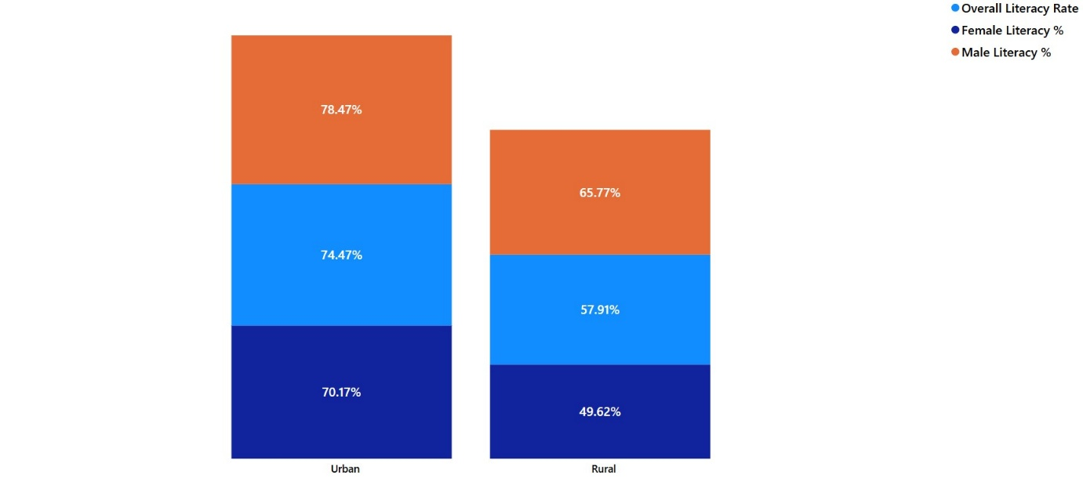

**5.b. Enrollment Trends by Education Level**: Use cluster column chart shows declining female participation beyond primary education.

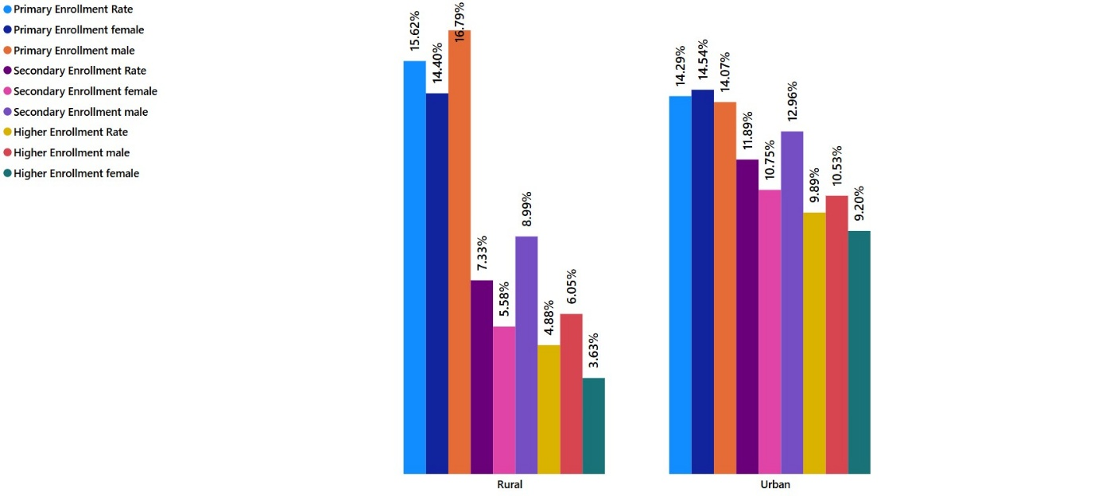

**5.c. Urban vs. Rural Literacy & Enrollment Rates**: Use stacked Column Chart reveals sharper gender gaps in rural settings.

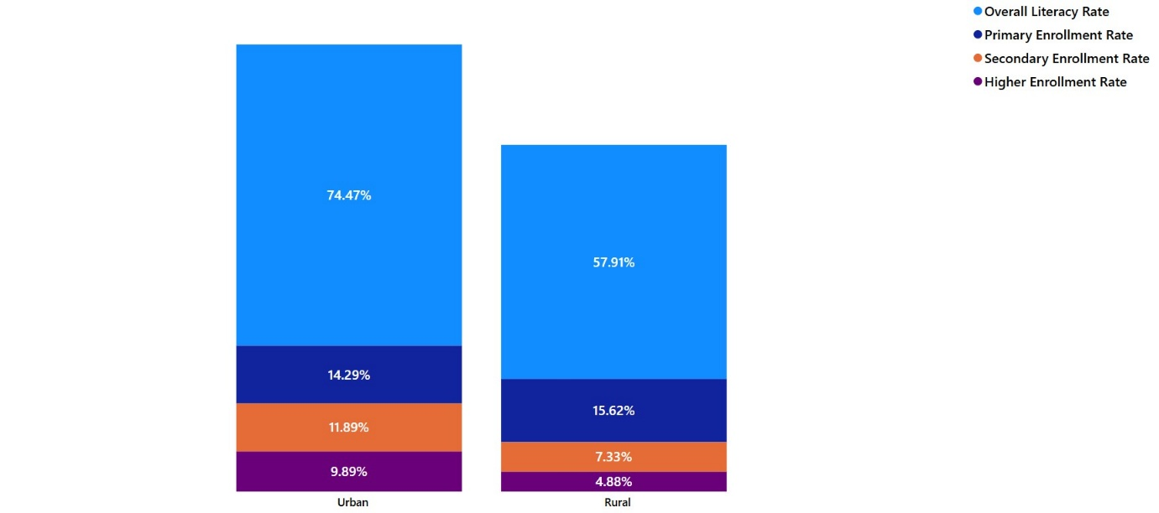

**5.d. Male vs. Female Literacy Rates by Age Group**: Use stacked bar chart indicates slower literacy growth among older female cohorts.

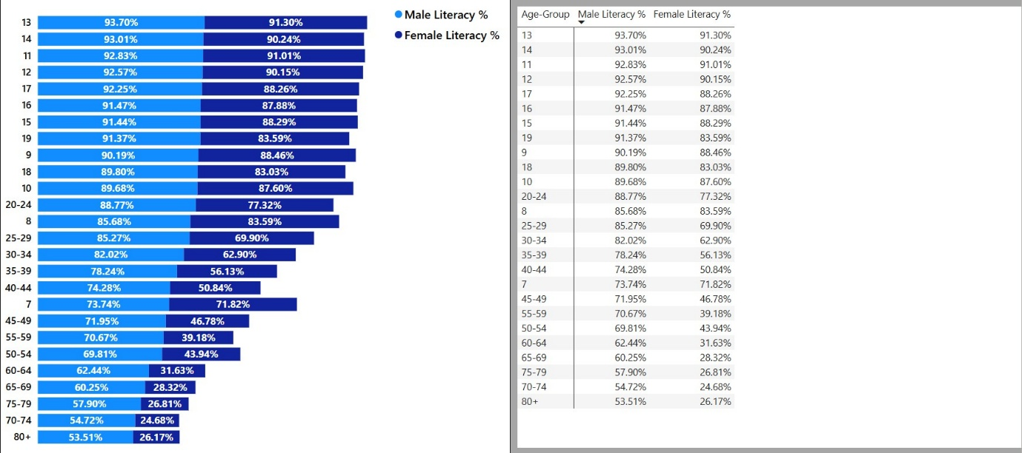

**6. Policy Implications**

**6. a) Focus Areas for Improvement**

* Upgrade rural school infrastructure, including digital learning tools and sanitation facilities.
* Expand adult literacy programs targeting women in tribal and underserved regions.
* Strengthen secondary and higher education pathways through financial aid, mentorship, and career guidance.

**6. b) Suggestions for Bridging Gender Divides**

* Introduce conditional cash transfers and targeted scholarships for girls.
* Recruit and train female educators to serve as role models in remote and tribal areas.
* Launch community-led campaigns to challenge gender norms and promote inclusive education.

**7. Data Sources**

* Census Data (2011, 2021)